**South End Sociology Final Paper**

Aj Olic, Alexander Weinberger, Gene Choi, Sofia Talman

**History of South End**

Before diving into some of the current events and present issues in the South End of Boston, one should be acquainted with a brief history of the neighborhood and some of the central characteristics of the area. The construction of the South End was part of a greater project that started in 1822, when the city of Boston started to fill in the marshlands of Back Bay and South Bay (a large interchange bordering Chinatown and the Leather District). Although the project went up until the 1890s, the South End was filled up by the 1870s. Similar to Back Bay, the marshland of the South End was filled up by using excavated gravel and sand from trenches in Needham, MA. Once the project was finished, Boston ended up with more than 5,000 acres of manmade land. Boston has more man-made land than any other city besides San Francisco). One of the largest mistakes of the past that is still haunting Bostonians today is that much of the 5,000 acres of land is supported by 30-40 foot long wooden beams that are rotting. These beams are long enough to reach beneath the level of where water runs, but recently droughts have pushed water very close to the top of the beams resulting in rotting. Costing at least $400,000 for a home’s foundation to be rebuilt, the city has put in safeguards such as the Boston Groundwater Trust in 1986 to track water levels throughout the city (How Boston Made Itself Bigger, 2021). Today the South End borders Back Bay, Chinatown, and Roxbury. The South End is has been known to be very diverse, with the Irish community being one of the most prevalent. A recent study shows “ In 2010, the population was 55.2% white, 13.3% Hispanic, 12.5% Black or African American, 16.2% Asian, and 2.7% other.” (BPDA, 2010).

Towards the end of the 1800s the South End was known as a tenement district. During this time some of the major changes in Boston included the arrival of new railroads, industry, anad even the financial panic of 1873. During the 70s the wealthy folk of the South End started to move to the more attractive Back Bay. Lower class immigrants, most of which being Irish, occupied the spots of the wealthy and much of the area turned into tenements. The Jews and the Italians of the South End (a high percent of the neighborhood’s population) mainly worked in factories and steam laundries. Due to the central location of the South End, many residents also worked in Chinatown (Global Boston, 2022).

Taking a large leap in time, the 1940s was a very important time for queer people. The South End became an attractive place for single gays and lesbians “The environment of single-sex rooming houses provided homes and social cover for unmarried gay and lesbian people to live together” (Meet Boston). This surge in the population of people from the LGBTQ+ community has stuck even today. Another huge part of the South End’s history is its history of jazz. In the 1920s-60s the South End became a hub for everything jazz related, and it became a home to many famous jazz clubs/bars. Some of the most famous clubs being: Hi-Hat, Pioneer Club, and Wally’s Paradise (Jazz Communities and Social Influence, Ethnomusicology Review). By the 1960s, the South End had become one of the poorest neighborhoods in the city due to absentee landlordism; this resulted in an increase in tenement housing. Despite a high density of gay people, artists, and overall cultural diversity, the rising costs to live in the South End threatens the character of the neighborhood. This shrinking of culture can also be seen in other cities such as New York City where its Little Italy and Chinatowns are shrinking in size year by year. A big difference between Boston and NYC is that NYC has protective policies already in place to reserve artists’ studios/galleries (especially in SoHo) whereas Boston does not have these safeguards.

Post WW2 the South End experienced suburban flight, disinvestment, and overall structural deterioration. In the 1960s-70s there was an increase in the black population along with people from Puerto Rico and the Dominican Republic. This redevelopment displaced “Jewish, Italian, and West Indian families” (Global Boston, 2022). Today, gentrification is more prevalent than ever and only the most prosperous of immigrant families can afford to live in the South End. Overall the neighborhood of the South End has a lower percentage of foreign-born residents when compared to the city of Boston as a whole (Global Boston, 2022).

**Race Matters - Gene Choi**

The journal discusses the impact of racism on urban housing and spatial practices in the United States. It critiques conventional accounts, namely those presented by Richard Rothstein, arguing that they fail to fully comprehend racism’s profound impact on the nature of American housing institutions. David Imbroscio demonstrates that racism is even more fundamental than people commonly believe it is, specifically in the context of market institutions and residential property values. He emphasizes the socially constructed nature of market institutions that reflect prevailing social values and biases. The pervasive racism in America significantly influences market values, affecting the assessment of property values, especially in residential areas. Imbroscio argues that racist beliefs infiltrate market values, challenging the notion of a racially neutral market.

The author then delves into the historical aspect, focusing on redlining as a practice where neighborhoods were designated as high risk for lending based on racial factors. He criticizes the conventional understanding of redlining for not fully grasping the structural causal dynamics. The argument is that redlining was not solely about individual racism but also about the codification of racist market rationality, where areas with black populations were considered investment risks due to prevailing racist beliefs. Imbroscio also questions the excessive blaming of the state for segregation injustices, proposing a more subtle view that acknowledges the state’s role without wholesale exoneration and emphasizes the need for a broader conceptual frame that recognizes the more profound, more fundamental role of racism in housing and spatial practices. Notably, he criticizes Richard Rothstein’s empirical perspective of excessively blaming the state for racial segregation and related injustices. The author points out that Rothstein attributes almost all racial injustices to de jure (by law) causes, oversimplifying the complex interplay of structural racism, market values, and government actions. Alternatively, he argues that racism is deeply embedded in the structural elements of American civil society and that government actions often align with socially constructed racist housing markets. Imbroscio highlights the historical evidence of white flight and racial segregation existing before widespread federal intervention. He argues that government actions are epiphenomenal to more significant structural forces, acknowledging the constraints on state power intrinsic to modern capitalist societies.

Furthermore, the author critiques Rothstein’s speculation that if black denizens had been able to move to suburbs during the mid-20th century, racial disparities in wealth could have been largely averted. He argues that this counterfactual overlooks the racist theory of value, which depresses property values in the presence of black residents, potentially undermining the equity accumulation envisioned by Rothstein. Imbroscio introduces the concept of “colored” property, emphasizing that property, especially in its residential form, has been racially marked, making market access and benefits constrained for black individuals. He challenges the notion that the problem lies solely in denied market access, arguing that this assumption fails to acknowledge the racially biased nature of markets. Studies show the devaluation of housing assets due to racial bias and the persistence of racial disparities in property values, even in affluent areas. The phenomenon of “colored” property is seen as an enduring social issue that affects black neighborhoods, limiting their economic well-being and making them vulnerable to predatory practices.

The author also critiques the conventional remedy, which addresses housing discrimination and promotes integration. While ending discrimination is crucial, integrative efforts often place unfair burdens on black individuals and may not effectively challenge the deeply embedded racist structures influencing property markets. He challenges the effectiveness and normative desirability of erasing black spaces as a solution to the racist theory of value, arguing that extreme integration levels are challenging to achieve and sustain. Imbroscio highlights the persistence of anti-black racism, discussing the growth of majority-black cities and suburban segregation. He questions the conventional remedy’s practicality and suggests that achieving racial equity requires addressing the deep-rooted issue of anti-black racism. The author concludes by offering correctives to the conventional view, asserting the need for a more profound acknowledgment of racism’s role as a causal force, the centrality of capitalism in shaping racial injustices, a focus on the racial and political-economic aspects rather than spatial, and a recognition of biased social ontology that influences perspectives on racial and class-based standpoints. He introduces various potential remedies, including racial reparations, universal social-democratic programs, and changes in capitalist ownership structures toward a property-owning democracy. Emphasizing the challenges and limitations of each approach, Imbroscio calls for a prolonged and committed struggle to overcome racial injustice.

The concept of systematic racism and discrimination applies to the ongoing issue of homelessness in South End as well. As mentioned earlier, systematic racism results in restrained market access, limiting housing opportunities for people of color and contributing to higher rates of homelessness within the South End. Racism plays a significant role in homelessness in the South End because South End is historically known for its substantial black population, and it continues to be one of the most diverse neighborhoods in the city of Boston. Since the South End is relatively close to the Port of Boston and the Boston Seaport District, it has been a common place for migration over a long time, attracting a diverse population, including black residents, who often settled right next to the urban centers, seeking for employment and opportunity. Due to its racially diverse demographic trends, South End is frequently subject to systematic racism, and as a result, racism has become an essential factor of homelessness in South End overall.

**Demographics (Yeejin Choi)**

**Abstract**: As the demographer of the South End group, I analyzed a variety of statistical data from the 2010 census. Our main issue within the South End neighborhood was housing and homelessness. The different types of data I concluded were relevant to our group study were **Housing Occupancy Status**, **Household Income by Race**, **Educational Attainment by Race**, **Racial Population Distribution**, and **Poverty Status**. The corresponding 9 census tracts for the South End were 070300, 070402, 070500, 070600, 070700, 070800, 070900, 071101, and 071201. One of the key factors contributing to homelessness in the South End that I decided to focus on was “race.” Throughout my analyses, I demonstrated how race plays a significant role in housing based on the census data collected via SimplyAnalytics.

**1. Housing Occupancy Status**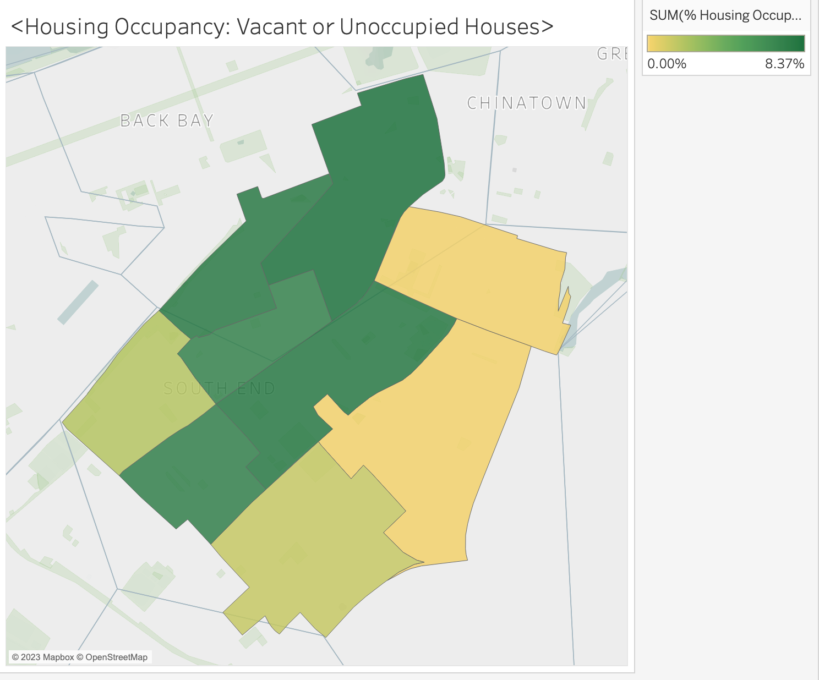

**Analysis**: More than half of the South End neighborhoods have at least 7% of vacant housing. I believe that vacant housing is related to homelessness because it represents unused resources that could potentially provide shelter for those experiencing homelessness. In a different perspective, higher vacancy percentage means that there might be a higher proportion of homeless people in that certain area. Moreover, vacant properties can negatively impact neighborhoods, potentially creating a sense of abandonment and reducing overall community stability. This environment might discourage local economic development and contribute to social issues that can exacerbate homelessness. Overall, I believe that housing occupancy status is one of the relevant factors of homelessness.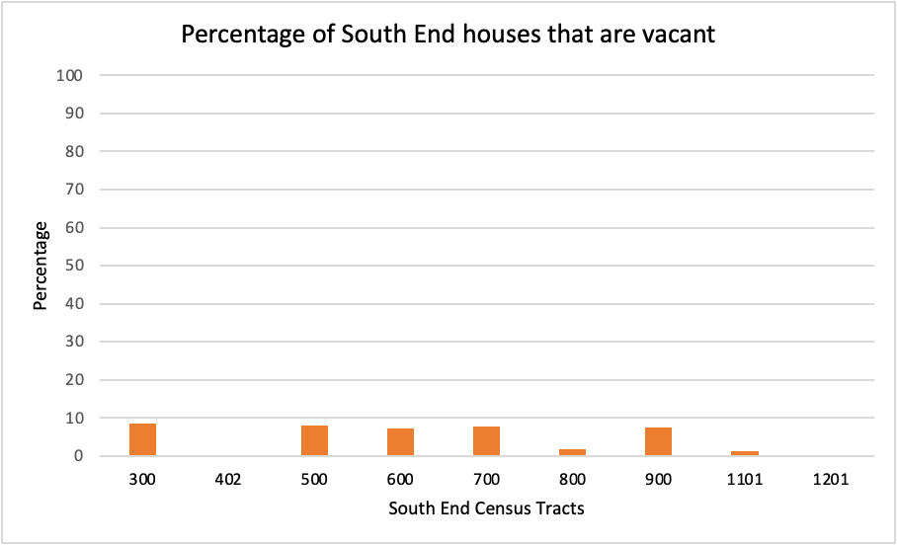

**2. Household Income by Race**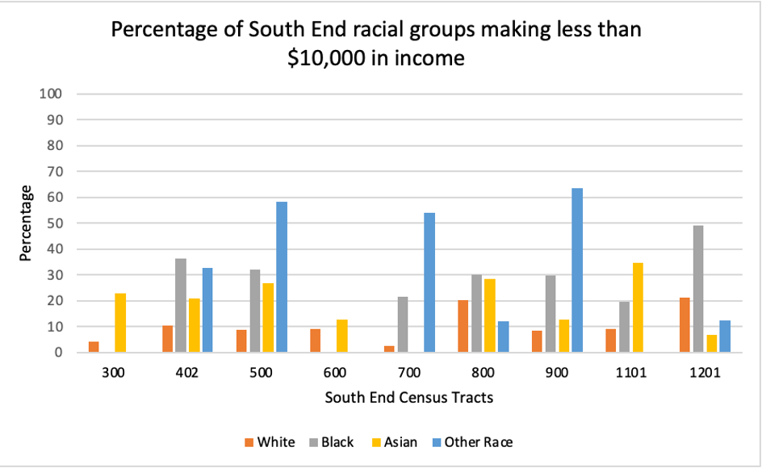

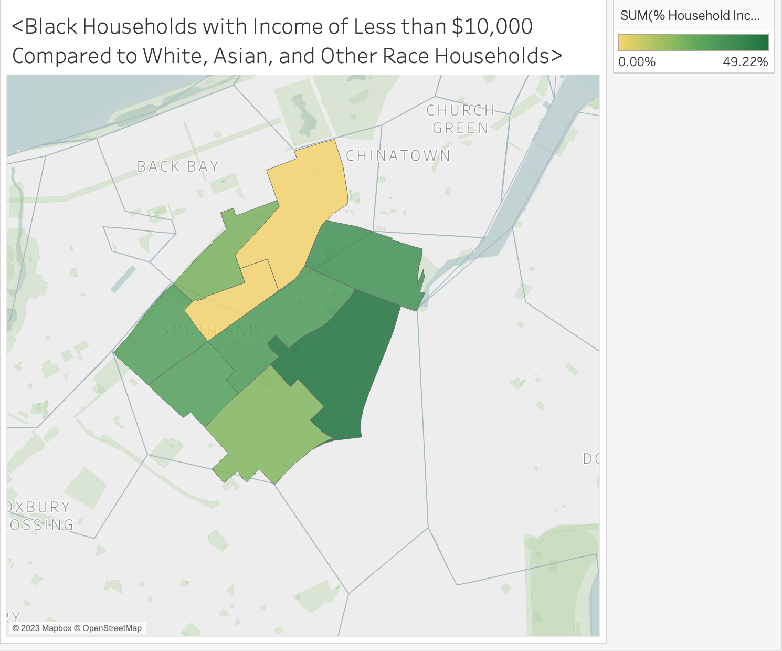

**Analysis**: For most of the areas in the South End, black and other race populations have a significantly higher percentage of an annual income less than $10,000. Low household income is a significant factor contributing to homelessness because low-income households often struggle to afford stable housing. As housing costs continue to rise, those with lower incomes may be forced into substandard living conditions or ultimately result in homelessness. Furthermore, individuals with low incomes may face higher rates of unemployment, and limited job opportunities and precarious employment conditions contribute to financial instability and hardship, making it harder to maintain housing. There is a higher likelihood of homelessness among people with financial difficulties and from the map and graph, we can assume that black and other race populations are more subject to homelessness in general.

**3. Educational Attainment by Race**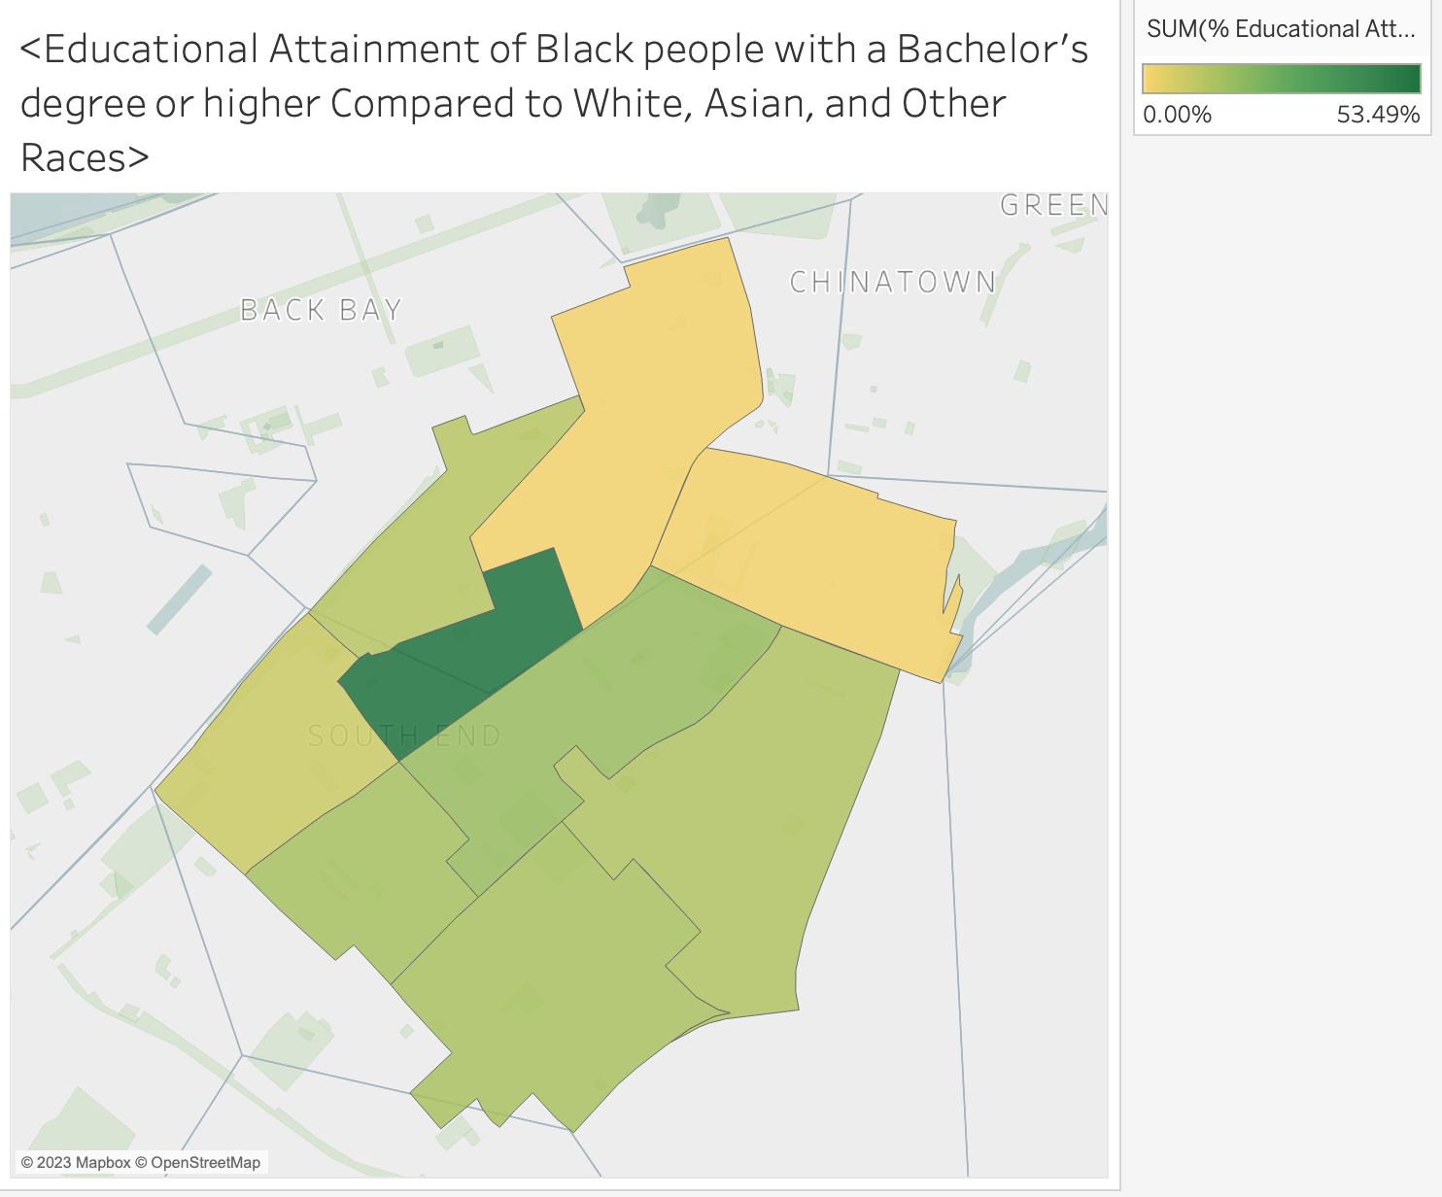

**Analysis**: Obviously, for most areas in the South End, black and other race populations have a significantly lower percentage of those who have an educational attainment of a Bachelor’s degree or higher. Lower education is directly related to homelessness as it represents lower quality of academic achievement and skill development, reducing individuals’ employment opportunities. This leads to lower income and increased vulnerability to economic instability, eventually leading to homelessness if one cannot afford expensive housing. Lack of education creates an endless cycle of financial hardship and homelessness, and the maps and graphs show that black and other race people tend to have a significantly higher percentage of people who did not attend college or receive further education beyond high school.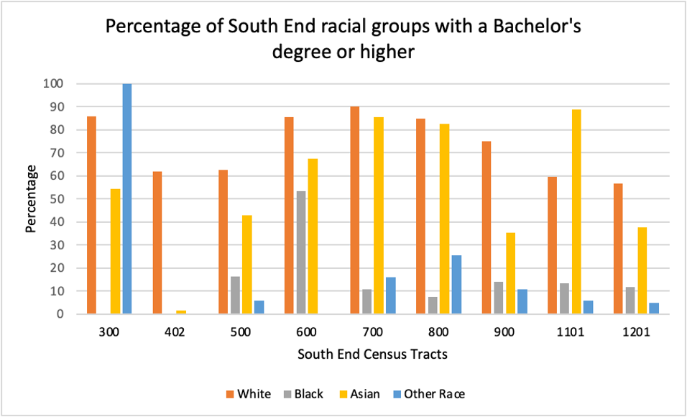

**4. Racial Population Distribution**

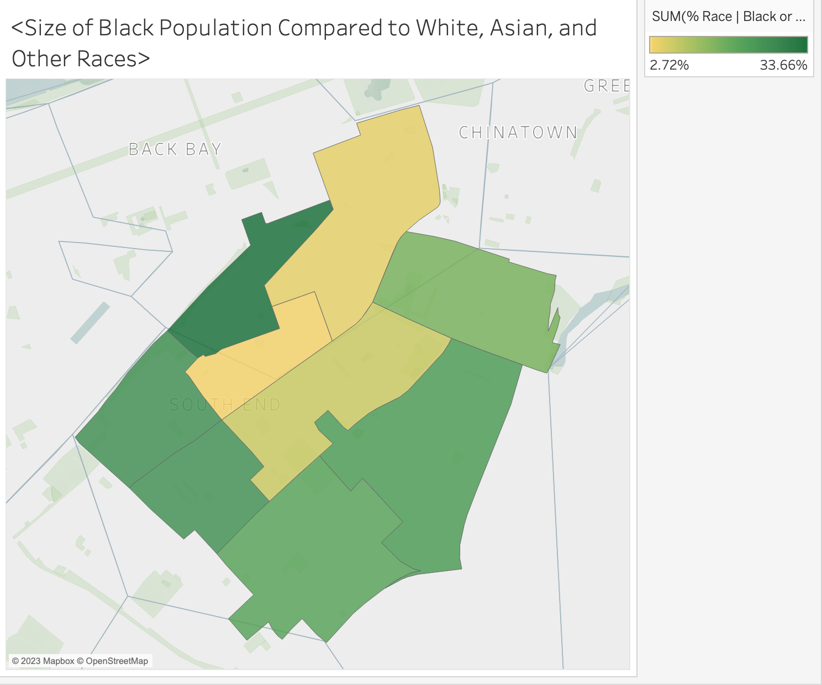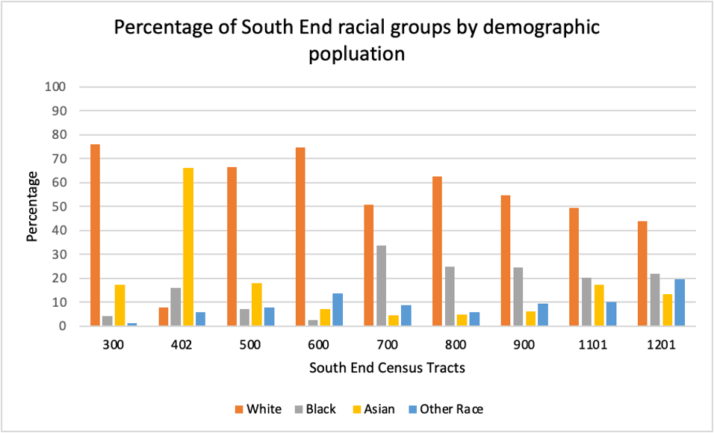

**Analysis**: The South End consists of a racially diverse people group where a significant proportion of the overall population consists of black people and other race people, which include Hispanics, Latinos, pacific islanders, etc. As shown in the previous graphs and data in part 1, 2, and 3, we can assume that black and other race people are relatively more subject to negative issues associated with homelessness, such as low education and low income. A high proportion of black and other race populations in the first place makes a particular area vulnerable to homelessness, and it altogether makes sense that there are housing issues and homelessness ongoing in the South End neighborhood.

**5. Poverty Status**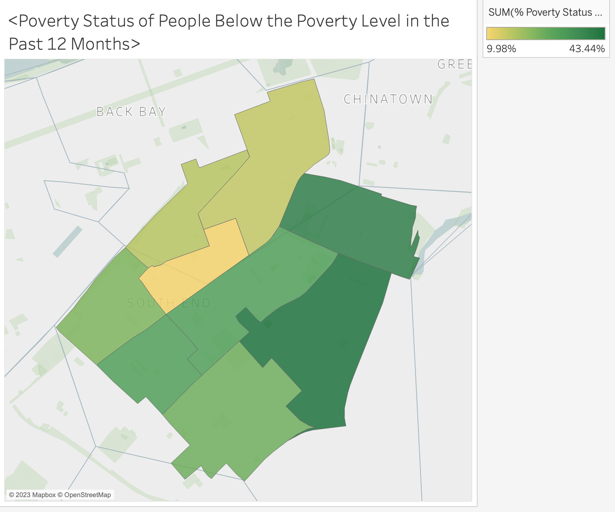

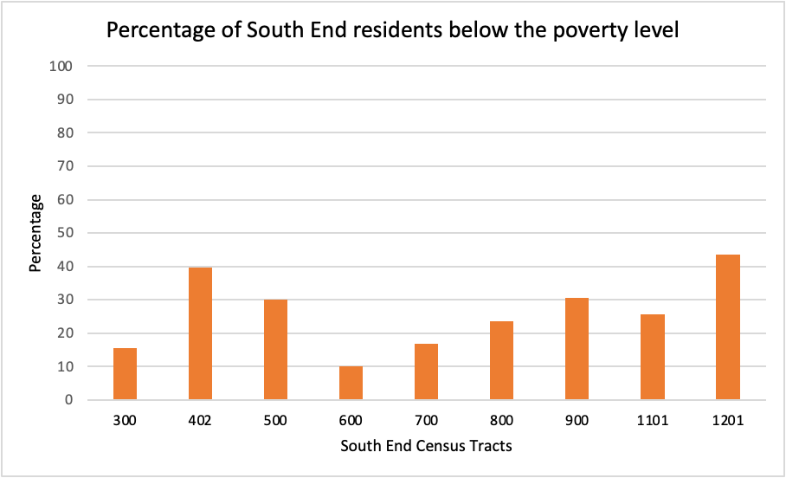

**Analysis**: We can clearly see that a majority of areas in the South End where the proportion of income below the poverty level is significantly high with a percentage of 30% or higher. Poverty issues are directly connected to homelessness since high poverty rates mean that a significant portion of the population lacks the financial resources to secure stable housing. In areas with elevated poverty rates, affordable housing options may be scarce, and this shortage can force individuals and families to face eviction and increase the likelihood of homelessness. Specifically, there exist structural issues within society that make it difficult to escape from the cycle of poverty such as systematic discrimination where it disproportionately affects economically disadvantaged populations mainly composed of black and other race populations, further deepening the connection between poverty and homelessness.

**Conclusion**: In conclusion, all five data shown above is related to housing issues and homelessness in the South End neighborhood. While all of these factors contribute to homelessness, we can observe evident racial patterns among these statistics. Ultimately, race does matter in terms of housing and homelessness.

# South End Map

# 

# 

When Robert Moses proposed a new highway running directly through Greenwich Village, a New York community led by Jane Jacobs protested and pushed for the preservation of the neighborhood. By unifying her community and mobilizing them to protest, Jacobs was able to successfully combat urban renewal during this redevelopment era. Beyond that, she advocated for cities to be a living, breathing, organism that was a space made for everyone living within it.

In the same decade in Boston, there was a similar protest in Boston’s South End. Historic brownstone buildings were being demolished under the guise of “urban renewal,” and South end was the next neighborhood targeted with the goal of building either a parking garage or luxury housing. Hundreds of people showed up to protest, led by the Bostonian version of Jane Jacobs, Mel King. They camped outside for days, creating a “tent city” where they continued to protest until they got their way. They eventually did, although it took 20 years to build the mixed used and affordable housing buildings.

What should’ve been a success story has since become borderline inhospitable housing. As one resident said, “The way they're running Tent City, it's not right, they don't care for us as tenants."1 It highlights Jacobs' idea that the abundance of people in a city leads to an abundance of problems. Although Tent City can be considered a victory in many ways, it will need large scale protests driven by the community for these changes to be seen.

**Photo’s:**

# **Tent City Apartments**

The Tent City apartment complex stands where the Tent City protests occurred almost 60 years ago, when the community camped out in protest of a parking lot being erected on the plot of land. Even after successfully earning affordable housing. The apartment complex was erected 20 years later.

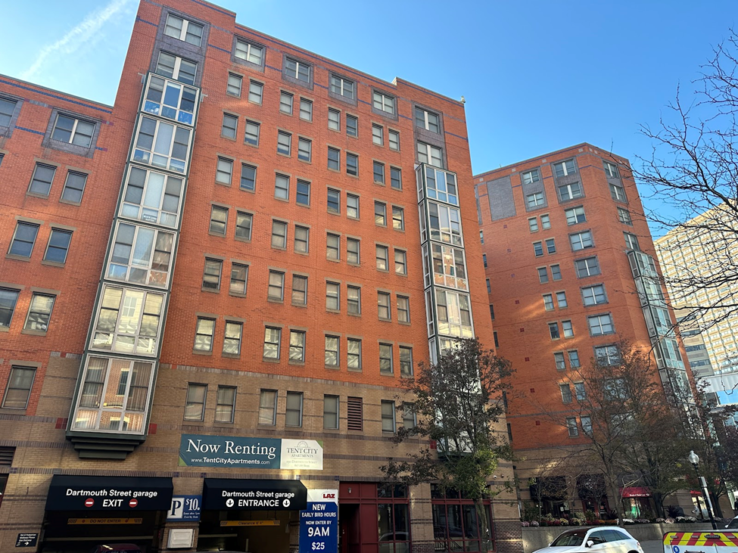

# **United South End Settlements**

The United South End Settlements is a program built to support economic mobility of families within the South End in hopes of increasing members' total assets to create generational stability.

# 

# **The Blackstone Innovation School**

Blackstone Elementary is one of many public schools that I encountered on my walk around the South End. It’s known for providing countless resources to the community, including but not limited to, community clinic, media center, gymnasium, media center, and much more. (The photo doesn’t fully capture the school clearly because I wanted to make sure I included the Puerto Rican flag.)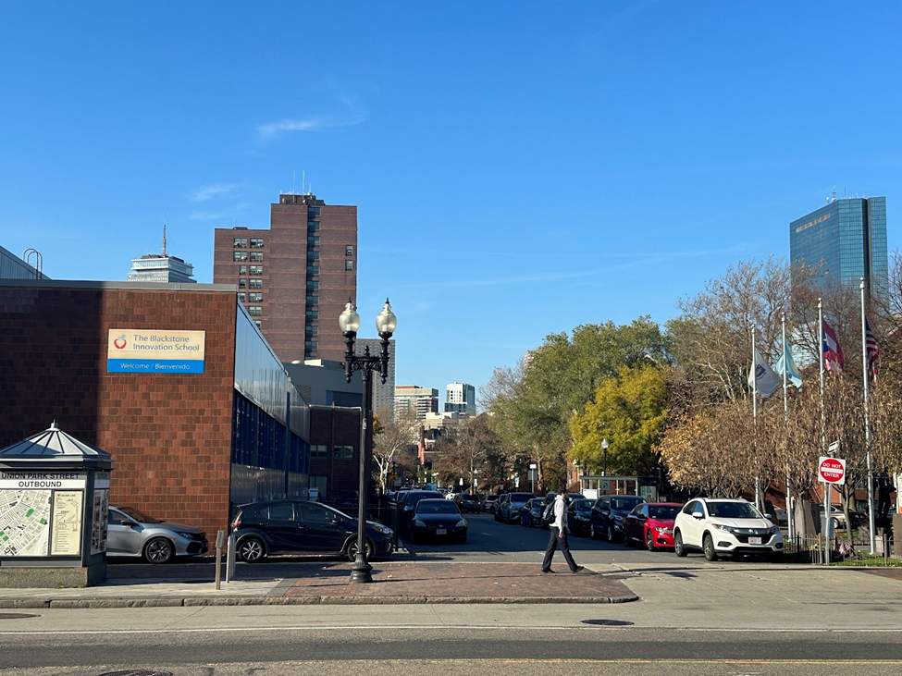

# **Hurley Field**

On the back wall of the building, a mural reads “SER BILINGUE ES MI SUPERPODER'' translating to “Being bilingual is my superpower.” It stood out to me because it implies that many of the students grew up in multilingual and multicultural homes, specifically Latin American. This also coincides with the large Puerto Rican presence in the South End.

# 

# 

# **Upton Plaza**

Albeit there isn’t anything truly special about this photo. I feel like it encompasses the “vibe” of South End very well. The rows of brownstone homes with a tree lined street were very prevalent throughout my walk around the neighborhood.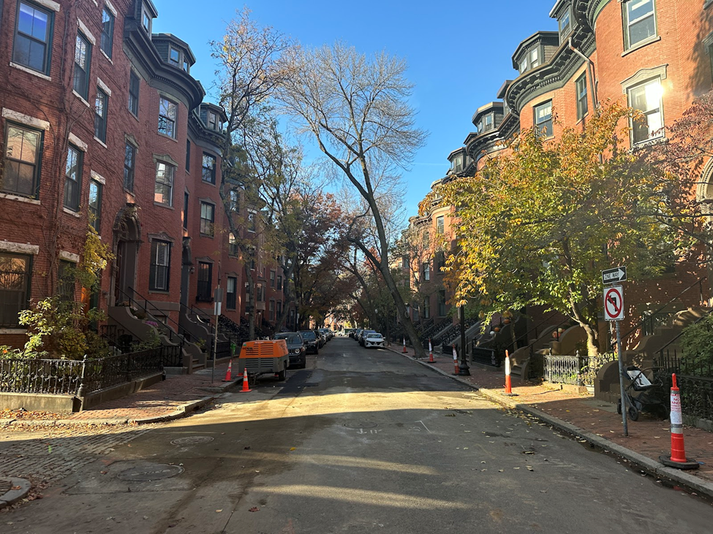

# **Franklin Square**

Since 1849, this park has served as a place for residents of the South End to enjoy nature and escape the urban landscape. It’s one of the many parks that engulfs South End.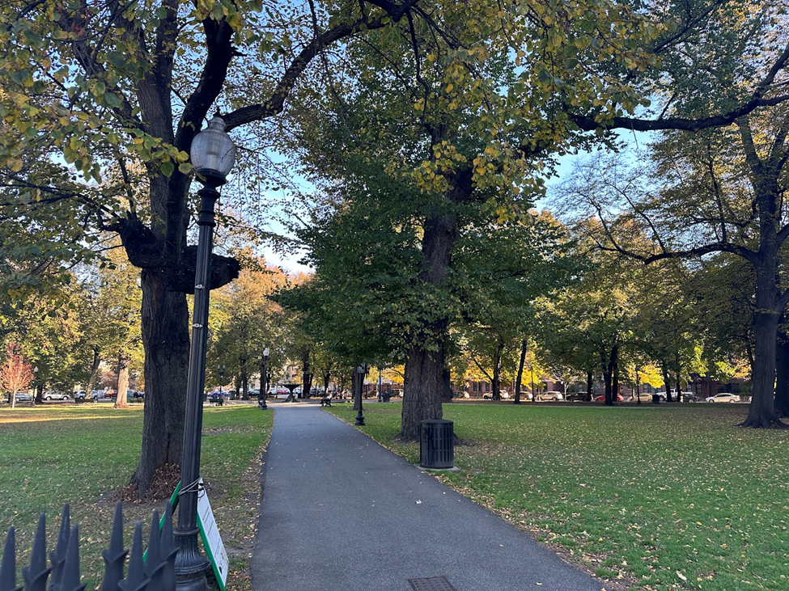

# 

# 

**Sofia Talman - Interview/Issues Section**

When walking around the South End personally, it’s important to note the juxtaposition between different areas. Some streets are covered in greenery and consist of statel brownstone buildings, the very picture of high end city living. Then a turn is made and the next street is filled with rickety fences and tightly packed low income housing, with evidence of poverty and poor living conditions obvious. Despite the differences in housing quality, one thing stands out - the cost of living is almost impossibly high. In an interview with South End resident Carrie, she mentioned rent as one of the biggest current issues in the area. The interviewer asked, “What, would you say, are some of the biggest issues concerning housing in this area?” Carrie’s response was immediate: “Rent! Rent is really, really expensive…if I were paying market rent for one bedroom … my one bedroom would be 2,400 dollars.” A striking observation when touring the area was the posting of real estate listings throughout the neighborhood. One apartment that was one bedroom, 800 square feet, was listed for a market price of $950,000.

This observation reflects a trend that has been growing exponentially since the 1990’s. According to this map (fig. 1) by Ugentry, a group that used data from the American Community Survey, rent in the South End was in the $250-$750 range in the 1990’s, and maintained little growth through the 2010’s. However, in the past decade, rent has faced an exponential increase of almost 5% a year, with the last two years witnessing a 26% rise in rent costs. This pattern is backed by Carrie’s testimony as well. When asked about the changes in the housing market over the course of her time in the South End, she responded, “I could've got a proper four [story] brownstone building for under 10,000 dollars back in the sixties, and now you're gonna pay almost ten million for it.” This observation is not incorrect, and also reflects a massive difference in housing prices that cannot be accounted for under the umbrella of the valuation changes in American currency. Back in the sixties, a single family home could be purchased for around $10,000-$20,000, and that figure has now grown to be around $450,000. That is a staggering 2,150% increase in cost, but that number is mild compared to the whopping 99,990% increase that Carrie references. This difference brings into bitter perspective the immense change residents of South End have witnessed when it comes to housing. 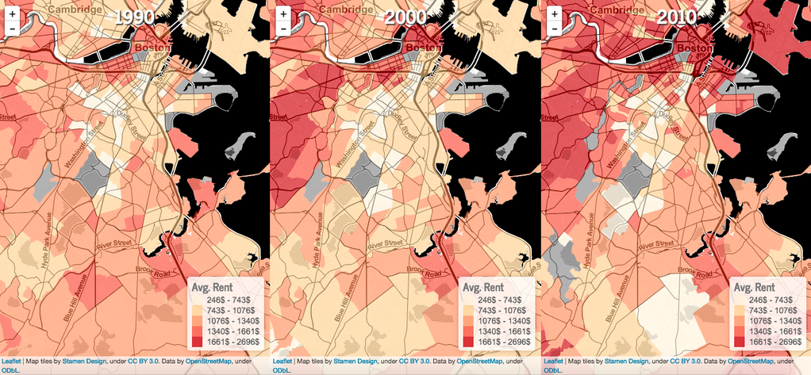

In light of these statistics, the question that remains is as follows: What is driving this massive increase in prices? There are a few factors that reflect this change- most notably the growth of Urban Renewal and gentrification efforts from private real estate sectors. Not only is the removal of a certain type of resident in the area prioritized in these efforts, but it’s important to note the typical race and class of said residents. An example of this is the near forced displacement of a massive Puerto Rican population in South End in the 1960’s. Early in the decade, the city made plans to demolish Parcel 19, a large Puerto Rican community living between Tremont and Washington streets. The urban renewal plan intended to demolish tenements that housed much of the Puerto Rican community, remodeling them into luxury housing projects and pricing out all of the residents in the area. This movement was combated by genius Puerto Rican activists and architects, who managed to work with the project leaders and create Victory Village, which has remained a Puerto Rican community to this day.

However, despite the history of successful South End activism, the private sector’s pursuit of urban renewal and gentrification has largely been winning the battle, with the South End now ranking third on a list of Boston’s most expensive neighborhoods. The phenomenon of racially targeted displacement and gentrification is not unique to the South End, or to Boston itself for that matter. In the article “If San Francisco, then Everywhere” by Richard Rothstein, the issue of gentrification and redlining is expanded upon with the example of neighborhoods in California primarily used.

Rothstein’s article “If San Francisco, Then Everywhere” details the progression of segregation in several Californian cities - a development that represents not only a horrific pattern in California itself, but throughout the country. The article begins with coverage of the segregation process in Richmond, CA, that skyrocketed during the wartime era in the 1940’s. Richmond became one of the most segregated cities in the country following a large industrial boom during World War II. A previous black population of 270 grew to 16,000, and the city struggled to find housing to accommodate this influx of workers (Rothstein, 2017). Several government-funded housing projects were constructed for both white and black workers, but the differences between the two were staggering. White public housing was in inner-city areas, with easy commutes and close proximity to other white neighborhoods. These constructions were built to be permanent living spaces, with room for the family and an additional sub-letter if needed.

Housing projects for black workers were vastly different - they were located in more isolated areas in much poorer parts of the city and were built to be temporary. Often, families would be forced to double up in these small and uncomfortable homes, and the living conditions were exceedingly difficult. Eventually, white working families were encouraged to move to suburban permanent homes, and black working families made up almost the entire public housing projects. This organization of housing remained in place long after the war ended and is largely responsible for the continuing issue of racial housing segregation in Richmond today.

This pattern is reflected in South End, Boston, particularly following the growth in its black population in the early 1940’s-60s. As redlining became more prevalent, the South End and surrounding areas are primarily in the red and yellow zones in early maps (See fig. 2). This structure of the area is largely responsible for the prevalence of low income individuals living in the South End, individuals that are facing the most risk of being displaced as urban renewal expands. It also corroborates recent statistics showing the rise in homelessness in the area. The main point that Rothstein communicates in this article is not only that segregation is a massive issue in these areas, but that it is representative of a much larger issue nationwide. California was not an area that was considered to be heavily segregated in this time period - it was often regarded as a very liberal area. If this issue is so prevalent in areas such as this, it is easy to infer that segregation is a resounding issue throughout the country. This rings especially true in Boston, particularly the southern districts. Boston is ranked as the 11th most segregated metropolitan area in the country, with increased homelessness as a result. One of the biggest struggles in the South End neighborhood of Boston is housing difficulties - they have a particular issue on a street nicknamed the “Methadone Mile.” This segment of the South End is known for staggering levels of homelessness and drug use, with very little assistance from the state and city governments. 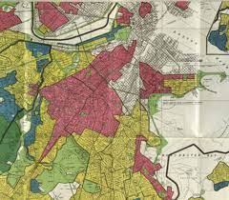

“Methadone Mile”, or “Mass and Cass”, is a segment of the South End that extends down the intersection of Massachusetts Avenue and Melnea Cass Boulevard, an area that has seen major homelessness and drug use. This issue became prevalent after the closure of a Long Island access point in 2014, of which some 700+ people used for access to homeless resources. The closure of this area resulted in the displacement of over 500 people, many of which migrated to Mass and Cass, making it the new “tent city” of Boston. In 2021, Boston Mayor Kim Janey issued an executive order geared at combating homelessness and addiction in the South End, enforcing the removal of homeless tents and communities. Rather than offering any form of rehabilitation, the city instead forced the removal of homeless encampments in these struggling areas - displacing the people that have already been displaced (Witowski 2022). Multiple efforts to offer rehabilitation have been shot down in the government, and the Methadone Mile remains an area rife with struggle and financial instability. This can be credited in part to the prevalent issue of redlining in the Boston area. A redlined map of Boston shows the districts south of Suffolk marked entirely in red and yellow, which happens to also be where a large population of homeless and minorities reside (Ofulue 2021). These racial disparities directly correspond with the housing crisis of the South End and the lack of government aid.

The prevalence of areas such as Mass and Cass coupled with the staggering price growth in the South End exemplify the pressing issue that is low income displacement. Gentrification, urban renewal, and redlining precedents continue to impact South End residents. Private sectors have managed to slowly price out low income residents, and as a result we’ve witnessed the South End get drained of the culture it used to be known for. Communities are chased out, low income families relocated, and even middle class buyers can’t find affordable housing.

Defilippis’ piece Place Matters (2016) is a response to a, then recent, edition of Place Matters. The piece focuses on issues addressed regarding segregation and spatial inequalities within metro areas. The first section of the piece focuses on the flaws of Place Matter’s takes on the dynamic relationship between the state and the private market. The lack of accountability towards the private sector is one of Defilippis’s main problems. He believes that focusing purely on the problems of the state makes it harder for there to be change in the future, especially in the markets. Defilippis proposes several problems with the authors’ takes. Along with claiming that autonomy of the people is forgotten when all eyes are on the state, Defilippis says that “there is no market without the state.” He believes that the market’s impact is inevitable. In his eyes it is absurd to say that the market is independent of the state, and he says that we must acknowledge that uneven development is an inherent trait to our capitalist society. The second part focuses on the relationship between space and society. Defilippis provides a perspective on how to interpret the borders of low and high-income areas; he distinguishes between a border and a frontier by giving the example of NYC’s Upper East Side and East Harlem. Overall, the second section focuses on the need for a more multidimensional approach to viewing economic segregation and poverty; such problems are not the outcomes of a single person’s or government agency’s act but the result of a multifaceted relationship.

This paper relates very closely to the South End’s problem with homelessness. This problem is most exacerbated on Massachusetts Ave and Melnea Cass Boulevard, AKA “Methadone Mile” (Witkowski, 2022). Since covid there have been three different mayors in office. Mayors Kim Janey and Michelle Wu, both of whom held mayoral positions during peaks of Covid-19, struggled and are still struggling to figure out how to properly rehabilitate and relocate the hundreds of people. Despite Defilippis’ piece being extremely theory heavy, much of what is discussed in the papers can be applied and observed in the South End today. Boston City Council President Ed Flynn is hoping that the crisis can be lessened by “decentralizing” services in the South End so that other cities and towns throughout Massachusetts can pitch in and take a say in how to help these people (McColgan, 2023). Similar to Defilippis’ views on the importance of a multidimensional approach to viewing economic segregation and poverty. Another direct application of Place Matters to the problem on Mass and Cass is the idea of the intersection being more of a frontier than a border. A local resident of the intersection, Domingos DaRosa says “[F]olks are coming out to find people defecating on their doorsteps, injecting themselves on their doorsteps, breaking into their cars to use not only a shelter but to use... to shoot up...” and “[T]he city continues to just put a Band-Aid on it...” (WCVB). It’s clear that the South End’s homeless problem is not confined just to Mass & Cass, but it’s spilling onto the neighborhood.

Although discussed through the lens of public housing and not homeless encampments, I believe that Lundquist’s take on perceived safety can be applied to the issue of homelessness in the South End. The section “Perceived Safety at DuBois'' talks about residents of the Philadelphia Housing Authority’s (PHA) DuBois Towers and their “[N]eed for the code” (Lundquist, 8), the code being a way to describe how low-income African Americans go about their daily routines. Said code can likely be applied to how one who lived on Mass and Cass may have lived their life. The idea of a sense of security is created via the common space at DuBois towers, despite their “violent context.” Although Mass and Cass was an intrinsically unsafe place to live, those with substance use disorder might have preferred to stay due to the accessibility of their choice of drug(s) and a sense of security by living with fellow users.

Although the Brookings presentation talks about moving housed people to better neighborhoods instead of fixing homelessness, I believe that some of the approaches can be molded to fit the homeless. Both policy approaches to improving upward mobility (improving the neighborhood approach and moving people to opportunity) can be applied to the situation of the former residents of Mass and Cass. The first approach is needed to understand how and why the homeless will be affected by their eviction (I.e., these people will never be able to live in the streets of the South End again without possibly being arrested). The moving to opportunity can be applied to the idea of relocating the homeless and the creation of new shelters. A relevant question that could be asked is: “how might the distance of one’s relocation affect their life (job wise, family wise, etc...)?”

Taking action and maintaining order was the goal of the state when clearing out Mass and Cass, and I think that Broken Windows provides a useful framework to view the actions of the state. Similar to Everyone Had Your Back, Broken Windows also talks about one’s perception of safety. In the case of BW, the perceived safety of Newark, NJ rose although the crime might have actually risen. The act of the police patrolling on foot was enough to make people feel safer. “Order” was achieved when the state of MA threatened the people of Mass and Cass with arrests. Residents of the encampment were compliant with the police and zero arrests were made while the camp was being cleared out. Massachusetts put a foot down and made it clear that no one is going to stay at Mass and Cass (essentially utilizing the broken window theory to show that MA won’t allow for anymore “crimes” to be justified and committed on Mass and Cass).

**Solutions**

With these solutions, our goal is to force new developments to increase their investment into the residents currently living in the community. With it, new projects from outside investors will be demotivated to create exuberant projects, which raise prices for residents. By implementing these, new projects will benefit South End and its crisis, while also displaying these luxury apartments that harm the vast majority of residents.

1. Require mandatory new housing projects to have a certain % of affordable housing.

This is a common strategy used nationwide, and it is extremely successful. South End does have a version of this, but nowhere near enough to supply the demand for affordable housing. We saw this in our interview with Carrie’s interview. She lives in one of these units, and has resoundingly positive reviews. Had it not been for this opportunity to live there, she would have been forced to move from her neighborhood and community.

1. New investments must allocate a certain % of total budget to combat the housing crisis.

This solution can be considered a defensive strategy due to the fact that it is openly accepting that new investments will happen. No matter that amount of low-income housing and government subsidies that the state puts into place, there will always be new money flowing into the South End. With this as a given, the state can direct some of the budget towards programs such as step by step housing programs to help transition the homeless into housing, rehab programs, mental health supports, supervised consumption sites, and programs alike.

1. Require affordable rent-to-own units in all new housing projects.

Although the idea of rent-to-own is somewhat controversial, requiring there to be units that are rent-to-own gives yet another opportunity for growth and makes it more feasible for once homeless people to possibly own a home in the future. Oftentimes the number one reason why middle class families can’t afford to and don’t end up buying homes in cities such as Boston is because of the down payment. A 20% downpayment (typical percent unless homebuyer is using an FHA loan) on a $500,000 apartment can easily deter a buyer from even making an offer. Another benefit of rent-to-own properties is that many of the contracts that potential homebuyers sign simply give the right to the tenant to purchase the property down the line, not the obligation (depending on whether the contract is lease-option or lease-purchase). One of the most obvious downsides to this type of contract is that the tenant might never own the property, but they will 100% pay more per month than if they were to rent.

**Works Cited**

1. (*Figure One):* Campion, T. (2015, March 25). *Average rent prices in Boston - mapped*. Campion and Company. <https://www.campionre.com/blog/posts/2015/03/25/mapping-boston-s-rent-prices-1990-2010/>
2. New York ; London : Liveright Publishing Corporation, a division of W.W. Norton & Company. (1970, January 1). *The color of law : A forgotten history of how our government segregated America : Rothstein, Richard, author : Free download, Borrow, and streaming*. Internet Archive. <https://archive.org/details/coloroflawforgot0000roth>
3. Homelessness crisis in Boston’s south end neighborhood | ACE. (n.d.). <https://ace-usa.org/blog/research/research-housing-policy/homelessness-crisis-in-bostons-south-end-neighborhood/>
4. (*Figure Two):* Ofulue, C. (2021, November 4). *Redlining in Boston: How the architects of the past have shaped Boston’s future*. The BPR. <https://www.bostonpoliticalreview.org/post/redlining-in-boston-how-the-architects-of-the-past-have-shaped-boston-s-future>
5. SimplyAnalytics (2023). SimplyAnalytics % Housing Occupancy Status | Vacant Data 2010. Retrieved November 18th, 2023, from SimplyAnalytics Database.
6. SimplyAnalytics (2023). SimplyAnalytics % Poverty Status In The Past 12 Months By School Enrollment By Level Of School For The Population 3 Years And Over [B14006] | Population 3 years and over for whom poverty status is determined | Income in the past 12 months below the poverty level Data 2010. Retrieved November 18th, 2023, from SimplyAnalytics Database.
7. SimplyAnalytics (2023). SimplyAnalytics % Race Data 2010. Retrieved November 18th, 2023, from SimplyAnalytics Database.
8. SimplyAnalytics (2023). SimplyAnalytics % Educational Attainment by Race | Bachelor’s degree or higher Data 2010. Retrieved November 18th, 2023, from SimplyAnalytics Database.
9. SimplyAnalytics (2023). SimplyAnalytics % Household Income by Race | Less than $10,000 Data 2010. Retrieved November 18th, 2023, from SimplyAnalytics Database.
10. SimplyAnalytics (2023). Map with 2010 SimplyAnalytics % Housing Occupancy Status | Vacant Data. Retrieved November 18th, 2023, from SimplyAnalytics Database.
11. SimplyAnalytics (2023). Map with 2010 SimplyAnalytics % Poverty Status In The Past 12 Months By School Enrollment By Level Of School For The Population 3 Years And Over [B14006] | Population 3 years and over for whom poverty status is determined | Income in the past 12 months below the poverty level Data. Retrieved November 18th, 2023, from SimplyAnalytics Database.
12. SimplyAnalytics (2023). Map with 2010 SimplyAnalytics % Race Data. Retrieved November 18th, 2023, from SimplyAnalytics Database.
13. SimplyAnalytics (2023). Map with 2010 SimplyAnalytics % Educational Attainment by Race | Bachelor’s degree or higher Data. Retrieved November 18th, 2023, from SimplyAnalytics Database.
14. SimplyAnalytics (2023). Map with 2010 SimplyAnalytics % Household Income by Race | Less than $10,000 Data. Retrieved November 18th, 2023, from SimplyAnalytics Database.
15. Mason, B. (2021, May 3). How Boston made itself bigger. Culture. https://www.nationalgeographic.com/news/2017/06/Boston-landfill-maps-history/
16. News & updates. Home | Boston Planning & Development Agency. (n.d.). http://www.bostonplans.org/
17. The south end. Global Boston. (2022, December 30). <https://globalboston.bc.edu/index.php/home/immigrant-places/the-south-end/>
18. Boston equality trail: History of equality in Boston. Meet Boston. (n.d.). https://www.meetboston.com/things-to-do/sightseeing-and-tours/walking-tours/boston-equality-trail/#:~:text=In%20the%201940s%2C%20the%20South,lesbian%20people%20to%20live%20together.
19. Jazz communities and Social Influence. Ethnomusicology Review. (n.d.). https://ethnomusicologyreview.ucla.edu/content/jazz-communities-and-social-influence
20. Witkowski, E. (2022). Homelessness crisis in Boston’s South End Neighborhood. Retrieved from https://ace-usa.org/blog/research/research-housing-policy/homelessness-crisis-in-bostons-south-endneighborhood/
21. McColgan, F. (2023). Retrieved from https://www.bostonherald.com/2023/08/24/wu-to-propose-4thsouth-end-shelter-in-mass-and-cass-plan-and-area-leaders-are-not-happy/
22. (2021). Retrieved from <https://www.wcvb.com/article/humanitarian-crisis-on-bostons-methadonemile-grows-worse/38006199>
23. Clampet–Lundquist, S. (2010). “Everyone had your back”: Social Ties, perceived safety, and public housing relocation. City &amp; Community, 9(1), 87–108. doi:10.1111/j.1540-6040.2009.01304.x
24. McDonald, D. (2023, January 8). Tent City, once a triumph of community activism, is now home to strife over maintenance and security - The Boston Globe. BostonGlobe.com. <https://www.bostonglobe.com/2023/01/07/metro/tent-city-once-triumph-community-activism-is-now-home-strife-over-maintenance-security/>
25. Place, opportunity, and social mobility: What now for policy? (2015). Retrieved from https://www.youtube.com/watch?v=AeuGKuniKyk
26. Wilson, J. Q., & Kelling, G. L. (2010). Wilson, James Q., and George L. Kelling: Broken windows theory. Encyclopedia of Criminological Theory. doi:10.4135/9781412959193.n281
27. City of Boston removes tent encampment at “Mass. and Cass.” (2023, November 1). WBUR.